JUN-AIR Oil free compressors Recommended Service Intervals

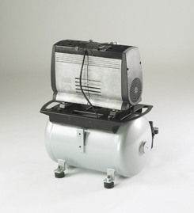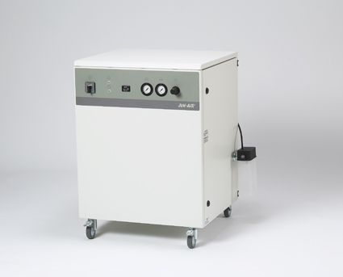

**2000 Hour or annual basic Service**

Intake air filters and non-return valves parts should be replaced every 2000 hours for maximum performance and protection of the motor. The intake filter should be changed more often when the motor is operating in extreme conditions with high levels of contaminants in the air. Non-return valve parts should be replaced every 2000 hours under normal operating conditions.

If the compressor is fitted with a (D) Desiccant dryer please refer to Dryer document below.

**As a condition of your 2 Year warranty you are responsible for properly maintaining your JUN-AIR compressor within the recommended Service intervals using genuine parts**.

|  |  |
| --- | --- |
| **Part number** | **Description** |
| 5470480 | Basic OF1201 |
| 5470485 | Basic OF1202 |
| 5470490 | Basic 2xOF1202 |

**Checking the pumping time (Compressors)**

The pumping time indicates the condition of the compressor provided there are no leaks in the system.

Test the compressor as follows.

* Empty the Air receiver of compressed air (the pressure gauge shows 0)
* Close the outlet on the air receiver and check drain cock is closed
* Start compressor and note how long it takes to achieve 8 bar/120 p.s.i. (See reference table below).

**Pumping time Reference table for OF1200 series**

|  |  |
| --- | --- |
| **Model OF1200** | |
| OF1202-40B | 1 min 50 sec |
| OF1202-40D | 2 min 10 sec |
| OF1202-150B | 6 min 50 sec |
| OF1201-25B | 2 min 25 sec |
| OF1201-40B | 3 min 35 sec |
| OF1201-40D | 4 min 20 sec |
| 2 X OF1202-150B | 3 min 25 sec |
| 2 X OF1202-150D | 4 min 5 sec |
| 3 X OF1202-150B | 2 min 40 sec |
| 2XOF1202-90B | 3min 09 sec |
| 2XOF1202-90Q | 3 min 48 sec |

|  |
| --- |
| Oil Free compressors basic Service Procedure  **Basic Service for OF1200 (Basic and Cabinet series)** |
| **Switch off compressor and isolate from mains supply** |
| * Drain receiver of any moisture and compressed Air * Cabinet models open both doors and remove cabinet lid |
| * Remove cover(s) and remove filter(s) (see dia below) |
| |  | | --- | | * Replace with new intake filter and re-assemble top covers | | |
|
|
|  |
| * Dismantle non-return valve(s) and replace both O-rings and spring (see dia below) |
| |  | | --- | |  | | |
|
|
|
|
|
|
|
|
|
|
|
|
|
|
| * Re-install the non-return valve(s) |
| * Clean compressor of any excessive dust as this can cause the compressor to over heat |
| * Start compressor and check for any leaks |
| * While compressor is running check safety valve by operating the pull ring (1) or by turning the screw (2) depending on the type of valve. |
| **Please be aware of loud noise while carrying out this procedure and always wear safety glasses to prevent eye injuries from expelled particles.** |
| |  | | --- | |  | | |
|
|
|
|
|
|
|
|
|
|
|
|
|
|  |
| * Cabinet compressors always make a visual check all cooling fans are working correctly  |  | | --- | |  | | | |
|
|
|
|
|
|
|
|
|
|
|
|
|
| * Cabinet models replace lid and close doors and secure | |

Basic Service for Desiccant Dryer (D Series)

Switch off Compressor and isolate from mains supply and always wear safety glasses.

Drain receiver of any moisture and compressed air.

* Loosen the metal bowl by hand by turning clockwise – do not use any tools –
* Replace filter elements (17), 0-ring (18) and possibly the auto drain of the pre-filter (16).



* Part numbers: Elements (17) Old 4081600, New 4081602. Auto drain float old 4087600 new (16) 4087602



* Re-assemble and fasten bowl by hand, start compressor and check for leaks.